**Re-platform Hands-on**

**Business Case**: For making use of cloud specific features for the Re-hosted application. Here the feature used is the AWS Relational Database Service (RDS). Migrate the database from the instance to a new AWS RDS Instance and connect the app to the new DB. The tool used here for migration is AWS Database Migration Service (DMS).

**Process**: Source server is the mariadb instance inside the xampp in the EC2 instance. Premigration testing is done on the source server. Create a new database in AWS RDS. Target server is this new RDS database. Database migration task migrates the data from source to target in a single migration. Application is then connected to the new database and postmigration testing is done.

**Main Tasks.**

1. Create DB.
2. Connect to the db in xampp from Workbench.
3. Premigration Testing.
4. Create a replication instance.
5. Create Endpoints.
6. Create Migration Task.
7. Test Schema and Data.
8. Connect app to new DB.
9. **Create MySQL DB in AWS RDS.**
   1. Log in to AWS Console.
   2. Go to RDS.
   3. Click Create database.
   4. Select
      1. Standard create.

* + 1. MySQL

* + 1. Version latest
    2. Free tier

* + 1. Give DB instance identifier, Master Username, password, Confirm password

* + 1. Remove autoscaling.

* + 1. Public access - Yes

* + 1. VPC security group - Create New
    2. Enter New VPC security group name.

* 1. Click Create database.
  2. Wait for DB to launch.

1. **Connect to the db in xampp from Workbench (MySQL DB of xampp is not exposed to outside).**
   1. Open Mysql Workbench in your laptop.
   2. Click on + near MySQL Connections.

* 1. In the Setup New Connection popup, Enter Connection name as “Rehost DB”, enter IP address in Host name, Port 3306, User name: root, Password: <blank>, Click Test Connection. Will get error.

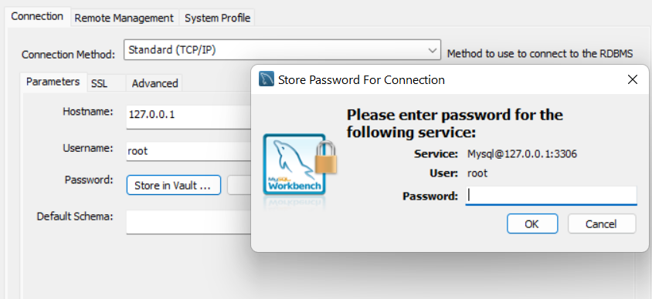

* 1. Open Port 3306 in AWS EC2 Security Group (Screenshots in Rehost Instructions Step 3.7).
  2. In the **windows server**, open port 3306 in Windows Firewall (Firewall -> Advance settings-> Inbound Rules -> Port 3306) (Screenshots in Rehost Instructions Step 3.8).
  3. Go to <http://localhost/phpmyadmin> , Server- > User accounts-> Click Edit Privileges for root user with grant as Yes -> Go to Login information -> Enter UserName:root, Host: Any Host, Password : root, Retype :root -> Click Go.

* 1. Connect again from Workbench.

1. **Premigration Testing.**
2. Test Data.
3. **Create a replication instance for AWS Database Migration Service.**
4. Go to Replication Instances section of the AWS DMS.
5. Click Create replication instance.
   * 1. Enter name, desc

* + 1. High Availability: Dev or Test

* + 1. Publicly accessible: Checked

* + 1. In Advanced security and network configuration, select the Sec Grp created while creating db.

1. Click Create.
2. Wait for replica instance to be up.
3. **Create Endpoints for migration.**
4. Go to DMS.
5. Go to Endpoints.
6. Click Create Endpoint.
7. Select Source Endpoint
   * 1. Enter Endpoint identifier, Desc
     2. Source Engine - MariaDB

* + 1. Click Provide access information manually.
    2. Server name : IP address of your aws windows
    3. Port : 3306
    4. Master username : root
    5. password: root

* + 1. Check if the Replica instance is done, if yes, Go to Test endpoint connection, choose the Replication Instance and Run Test.
    2. Click Create Endpoint.

1. Click Create Endpoint.
   * 1. Select Target Endpoint.
     2. Select RDS DB instance, pick the DB created earlier.

* + 1. Enter Endpoint identifier, Desc
    2. Target Engine - MySQL
    3. Click Provide access information manually.
    4. Server name : will be filled
    5. Port : 3306
    6. Master username : what was given earlier.
    7. password: what was given earlier.
    8. In Endpoint settings, check Use endpoint connection attributes.
    9. Enter initstmt=SET FOREIGN_KEY_CHECKS=0 in Extra connection attributes.

* + 1. In Test endpoint connection, click Run Test.
    2. **If not successful, check the Security Group for the RDS DB**.

* + 1. Click Create Endpoint.

1. **Create Migration Task**
2. Navigate to the Database migration tasks section of the AWS DMS
3. Click Create task.
   * 1. Enter Task identifier.
     2. Choose Replica, Target, Source.

* + 1. In Table mappings, click Add new selection rule.
    2. Schema : Enter a Schema
    3. Schema name : %
    4. Uncheck “Turn on premigration assessment”.
    5. Click Create.
    6. Wait till task is created, Loaded and Completed.

1. **Test Schema and Data.**
2. Connect to the new DB from Workbench.
3. Test the data.
4. **Connect app to new DB.**
5. Go to C://xampp/application/config/database.php, update the DB details.
6. Check Application.
7. Perform regression testing, Exploratory Testing.
8. Note Down test cases and bugs.